Date: DD/MM/YYYY

**ENERGY AUDIT REPORT FOR BUILIDNG COOLING SYSTEM**

**FOR**

**ENTER BUILDING NAME**

**At**

**ENTER BUILDING ADDRESS**

**(BUILDING IMAGE)**

**Submitted By**

Enter name of PE/Energy Auditor

Signature of PE/Energy Auditor

|  |
| --- |
| Enter No. |

**PE (Mech) Registration No*:**

**Energy Auditor Registration No*:** Enter No.

*Delete whichever is not applicable

Table of Contents

1.0 Executive Summary & Recommendation 3

2.0 Building Information 3

3.0 Energy Audit Information for Building Cooling System 4

3.1 Chilled Water Plant Design information* 5

3.2 Chilled Water Plant Normal Operating Hours 7

3.3 Description of Plant Control Strategy 7

4.0 Instruments 9

5.0 Chiller Plant Performance Analysis (1-week data) 10

5.1 Summary of Chilled Water Plant Operating Performance 19

6.0 Summary of Heat Balance 20

7.0 Schedule of space operating conditions 21

APPENDIX A: Checklist of Plant Operating Condition (best practices) 22

APPENDIX B: Temperature Sensor Verification Plot 23

# 1.0 Executive Summary & Recommendation

(Example)

**This report highlights the findings and recommendations obtained from the energy audit performed at Enter Building Name from [Enter Period of Audit] DD/MM/YYYY to DD/MM/YYYY for 24 hrs.**

**Corrective measures taken by PE (Mech)/ Energy Auditor to comply with PEA Notice.**

1. *<Description of findings/ measures>*
2. *<Description of findings/ measures>*
3. *<Description of findings/ measures>*

**Recommended energy improvement measures for Building Owners:**

1. *<Description of recommendations>*
2. *<Description of recommendations>*
3. *<Description of recommendations>*

# 2.0 Building Information

*Enter a brief description of the building here.*

Project Reference Number :

Building Name :

Building Address :

Postal Code :

Building Type :

Building Age :

Date of last Energy Audit Submission :

Gross floor area (GFA), m2  :

Air-conditioned area, m2 :

Number of guest rooms :

(for hotels/service apartments)

# 3.0 Energy Audit Information for Building Cooling System

**PE(Mechanical) / Energy Auditor Name** was appointed by **Owner Name/ MCST**, owner of **Building Name** to be the Energy Auditor for the 3-yearly submission of the operating system efficiency (OSE) of the centralized Chilled Water Plant. The report will present the performance of centralized Chilled Water Plant efficiency based on the measurements from the permanent instrumentations installed on site.

|  |  |
| --- | --- |
| Location : | **Enter location of Chilled Water Plant** |
| Energy Audit Period : | **Enter Energy Audit period** |
| Date of notice served (*if any*) : | **Enter date of notice served by BCA** |
| Date of submission in notice : | **Enter submission deadline stipulated in BCA notice** |
| Minimum TSE to comply with : | **Enter Min OSE requirement for Chilled Water Plant**  **(GLS/ non-GLS)** |
| Data Logging Interval  **:** | 1-minute sampling |
| Trend Logged Parameters* **:** | Chilled Water Supply main header temperature |

Chilled Water Return main header temperature

Chilled Water flow rate at chilled water return main header

Condenser Water Supply main header temperature

Condenser Water Return main header temperature

Condenser water flow rate at condenser water return main header

Power input to Chiller(s)

Power input to Chilled water pump(s)

Power input to Condenser water pump(s)

Power input to Cooling tower(s)

***Note 1: Trend logged parameters are not limited to the above and may vary depending on the piping and electrical circuit design.***

***Note 2: The minimum logging period is one week.***

## 3.1 Chilled Water Plant Design information*

|  |  |  |  |  |  |  |  |  |
| --- | --- | --- | --- | --- | --- | --- | --- | --- |
| **ID** | **Description** | **Brand Name** | **Type** | **Name plate motor (kW)** | **Total Cooling Capacity (RT)** | **Chilled water LWT/EWT** | **Rated Efficiency (kW/RT)** | **Year Installed** |
| CH01 | Chiller 1 | <Input name> | centrifugal, water-cooled | 162.8 | 300 | 7.5 °C | 0.543 | 2021 |
|
|
| CH02 | Chiller 2 | <Input name> | centrifugal, water-cooled | 162.8 | 300 | 7.5 °C | 0.543 | 2021 |
|
|
| CH03 | Chiller3 | <Input name> | centrifugal, water-cooled | 162.8 | 300 | 7.5 °C | 0.543 | 2021 |
|
|

**Table 1: Chiller Information (Example)**

|  |  |  |  |  |  |  |  |  |  |  |  |  |
| --- | --- | --- | --- | --- | --- | --- | --- | --- | --- | --- | --- | --- |
| **ID** | **Brand** | |  | **Type** | |  | **Name Plate motor (kW)** |  | **Pump Head (m)** | **Flow rate (L/S)** | **Rated Pump/Fan efficiency** | **Rated Motor Efficiency** |
| CHWP 1 |  | Brand | X |  | end suction |  | 11 |  | 23 | 33.65 | 80.0% | 92.4% |
|  |  |
| CHWP 2 |  | Brand | X |  | end suction |  | 11 |  | 23 | 33.65 | 80.0% | 92.4% |
|  |
| CWP 1 |  | Brand Y |  |  | end suction |  | 15.0 |  | 16.0 | 56.82 | 79.0% | 92.4% |
|  |  |
| CWP 2 |  | Brand Y |  |  | end suction |  | 15.0 |  | 16.0 | 56.82 | 79.0% | 92.4% |
|  |
| CT 1 | Brand Z | |  | cross flow | |  | 5.5 x 1 Cell |  | - | 66.2 | 75% | 86% |
| CT 2 | Brand Z | |  | cross flow | |  | 5.5 x 1 Cell |  | - | 66.2 | 75% | 86% |

**Table 2: Ancillary equipment Information (Example)**

**\*Based on equipment design specifications and name plate ratings**

## 3.2 Chilled Water Plant Normal Operating Hours

Monday to Friday : 1000 – 2100 Hrs

Saturday / Sunday : Based on actual operational hours

***Note****: The operating hours should follow the table in clause 6.1.4*

## 3.3 Description of Plant Control Strategy

Summary of the present plant control strategy adopted for the applicant’s building chiller plant systems’ operation. You may include but not limited to the following:

1. **Chiller sequencing**

*Describe how the chiller(s) operate to handle the varying building cooling load*

*e.g. chiller cut-in/out sequence varying with building load and addressing peak and off-peak load based on (supply water temperature, and/or building load, and/or compressor current running load amps) and time delay.*

1. **Chilled water pump (if applicable)**

*Describe the parameters used to control chilled water pumps*

*e.g. pump speed modulate based on ((differential) pressure sensor located at chiller header, or remote AHU cooling coil, or several zones of AHU cooling coil, or optimising pump pressure by critical valve control), set-point(s) and bypass valve controls to ensure chillers operate at minimum flow rate*

1. **Condenser water pump (if applicable)**

*Describe the parameters used to control condenser water pumps*

*e.g. modulate to maintain condenser water differential temperature set point or gpm/ton and the set-point(s).*

1. **Cooling tower (if applicable)**

*Describe the parameters used to control cooling towers*

*e.g. Modulate base on cooling tower approach temperature (difference between CT leaving water temperature and ambient wet-bulb temperature) set point (adjustable), or scheduled cooling tower leaving temperature set point, or dynamic optimized cooling tower leaving water temperature set point and the set-point(s)*

1. **Other optimisations (if applicable)**

*Describe any other optimisation used*

*e.g. Chilled water supply temperature reset. At off-peak period, reset based on outdoor air temperature/humidity, or VPF bypass control, or predefined schedule. (Note: Resetting CHW temperature may incur higher pump power and may compromise on space temperature and relative humidity)*

*(Examples)*

**Chiller Configuration:** *<x>* **unit(s) of** <*x>* **RT chiller** **&** <*x>* **unit(s) of** <*x>* **RT chiller**

**Variable Primary Chilled Water System**

**Variable Condenser Pump**

1. **Chiller sequencing**

***Scenario for Cut-in:*** *Chilled water supply header temperature is above set point of <x> °C + <deadband> OR total system tonnage is above <x> RT for a period of <x> minutes.*

***Scenario for Cut-out:*** *Chilled water supply header temperature is below set point of <x> °C + <deadband> AND total system tonnage is below <x> RT for a period of <x> minutes.*

***Time delay:*** *Whenever any chiller cuts-in/out, there is <x> minutes delay to allow system to stabilize.*

1. **Chilled water pump (CHWP)**

*Primary CHWP speed is modulated to maintain a differential pressure set point of <x> psi + <deadband>. Differential pressure sensors are installed at chilled water pipe headers. CHWP speed is limited to <x> Hz to ensure chillers running at minimum flow. When CHWP speed ramps down to minimum and differential pressure rises above set point, the bypass valve will open to maintain DP set point and minimum flow rate.*

1. **Condenser water pump (CWP) <fixed/variable>**

*Minimum running speed of CWP is <x> Hz. When condenser flow rate is reduced to set point of <x> l/s or <x> gpm/ton, CWP speed would be increased and vice versa.*

1. **Cooling Tower (CT)**

*CT fan speed is modulated to maintain leaving condenser water temperature set point of <x> °C which is equal to outdoor air wet-bulb temp plus <x> °C. When chiller(s) is in operation, all CTs would be turn on. When CT leaving water temperature falls below the set point, CT fan speed would be decreased until minimum speed of <x> Hz.*

1. **Other Optimisation**

*Chilled water temperature set point is reset to <x> °C during off-peak period from 2000hrs to 0800hrs.*

# 4.0 Instruments

Accurate measuring instruments complying with the Code on Environmental Sustainability Measures for Existing Buildings or the Code for Environmental Sustainability of Buildings (2nd edition and onwards) that is prevailing at the time of installation were used during the audit to gather information on the power consumption, temperatures and flow rate.

The points of measurements are listed in the following table:

**Table 3: Instrumentation Table (Example)**

|  |  |  |  |  |  |  |  |
| --- | --- | --- | --- | --- | --- | --- | --- |
| **ID / Serial No.** | **Description** | **Sensor Type** | **Installation Location** | **Measurement/ Calibration range** | **Measurement Uncertainty (%)** | **Last Calibration Date** | **Calibration Laboratory** |
| EP80367 | Brand X Temperature Sensor | 10K Ω Thermistor | CHWS Header | 0.01°C – 29.765°C | ±0.03 °C | 17/9/2021 | XX laboratory |
| EP80361 | Brand X Temperature Sensor | 10K Ω Thermistor | CWS Header | 0.01°C – 29.765°C | ±0.03 °C | 17/9/2021 | XX laboratory |
| EP80363 | Brand X Temperature Sensor | 10K Ω Thermistor | CWR Header | 0.01°C – 29.765°C | ±0.03 °C | 17/9/2021 | XX laboratory |
| 3k67201343 | Brand Y CHW Flow Meter | Magnetic Full Bore | CHWR Header | 0 l/s- 288.63 l/s | 0.50% | 9/5/2021 | factory calibration |
| 3k67201418 | Brand Y CW Flow Meter | Ultrasonic | CWR Header | 0 l/s- 483.33 l/s | 0.50% | 9/5/2021 | factory calibration |
| 38490 | Brand Z Incoming Power Meter | True RMS | MSB Incoming | 0 – 100MW | 1% | 9/5/2021 | factory calibration |
| 38491 | Brand Z Chiller Power Meter | True RMS | CH/6-1 | 0 – 10MW | 1% | 9/5/2021 | factory calibration |
| 38487 | Brand Z Power Meter CHWP | True RMS | CHP/6-1 | 0 – 100kW | 1% | 9/5/2021 | factory calibration |
| 38499 | Brand Z Power Meter CWP | True RMS | CWP/6-1 | 0 – 100kW | 1% | 9/5/2021 | factory calibration |
| 38572 | Brand Z Power Meter CT | True RMS | CT/6-2 | 0 – 100kW | 1% | 9/5/2021 | factory calibration |
| 38486 | Brand Z Current Transformer | Three phase | CH1 | Ratio 100:5 | 1% | 9/5/2021 | factory calibration |

# 5.0 Chiller Plant Performance Analysis (1-week data)

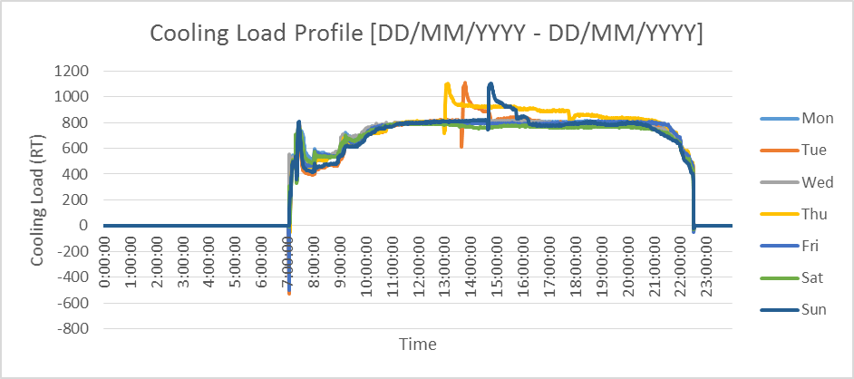

Ave (10am

-

9

pm)

=

799RT

##### Figure 1: Super-imposed plot of 24 hr Cooling Load Profile RT (Example)

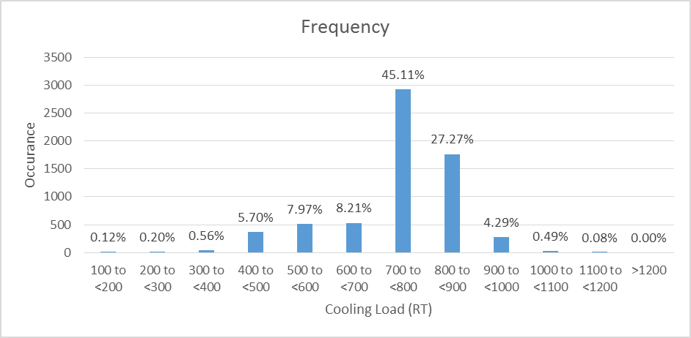

##### Figure 2: Histogram of Cooling Load Occurrences (Example)



##### Figure 3: Super-imposed plot of daily chilled water supply/return temperature oC (Example)

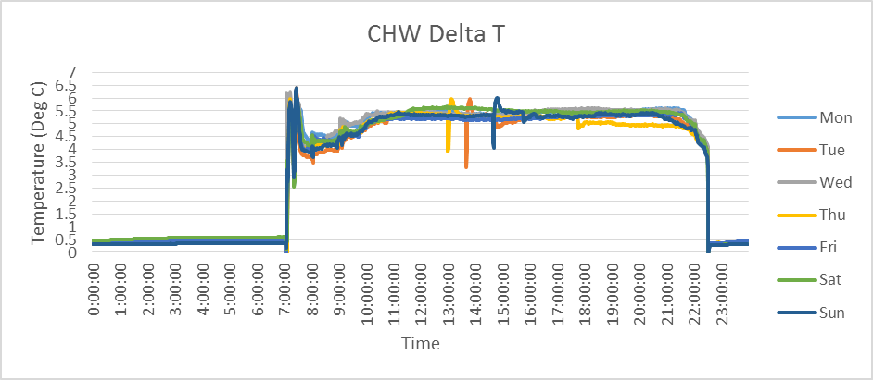

Ave (10am

-

9

pm)

=

5.4

o

C

##### Figure 4: Super-imposed plot of daily chilled water temperature difference oC (Example)



##### Figure 5: Super-imposed plot of daily condenser water supply/return temperature oC (Example)

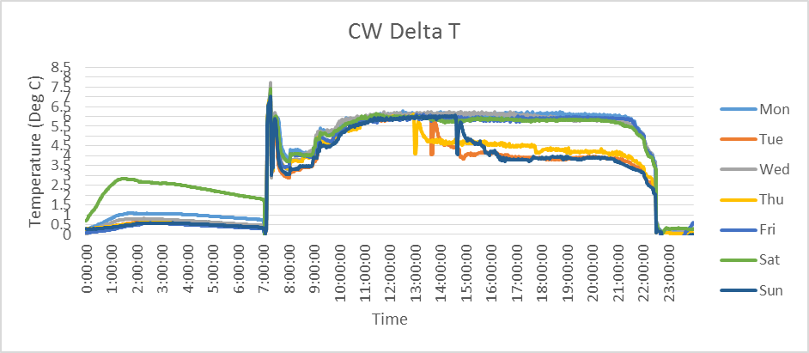

Ave (10am

-

9

pm)

=

6.05

o

C

##### Figure 6: Super-imposed plot of daily condenser water temperature difference oC (Example)

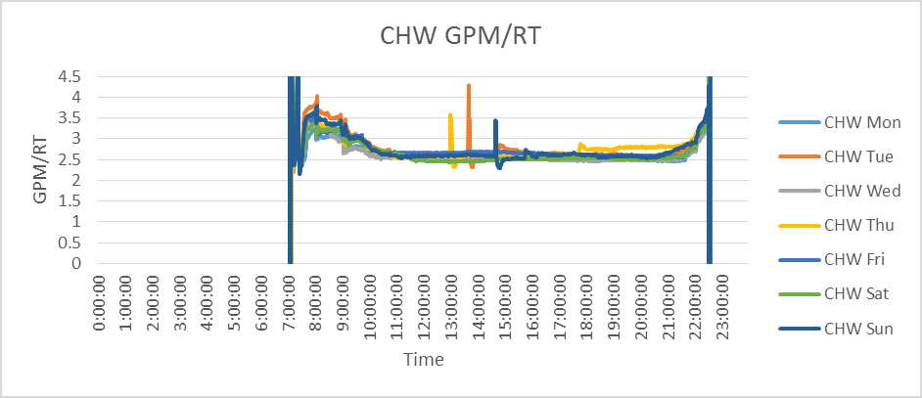

Ave (10am

-

9

pm)

= 2.59

##### Figure 7: Super-imposed plot of daily chilled water GPM/RT (Example)

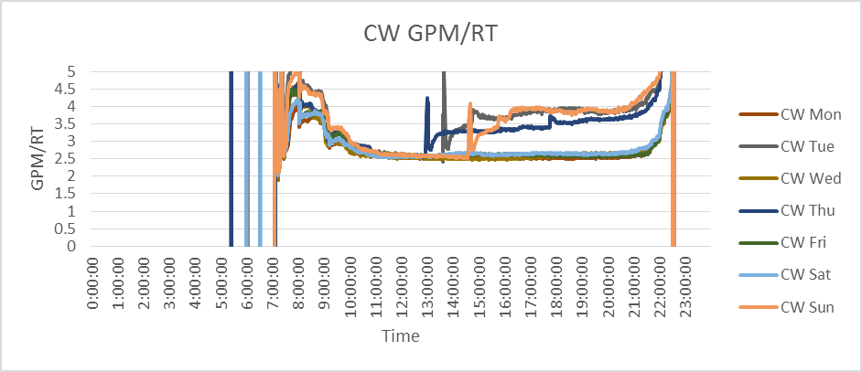

Ave (10am

-

9

pm)

= 2.9

##### Figure 8: Super-imposed plot of daily condenser water GPM/RT (Example)

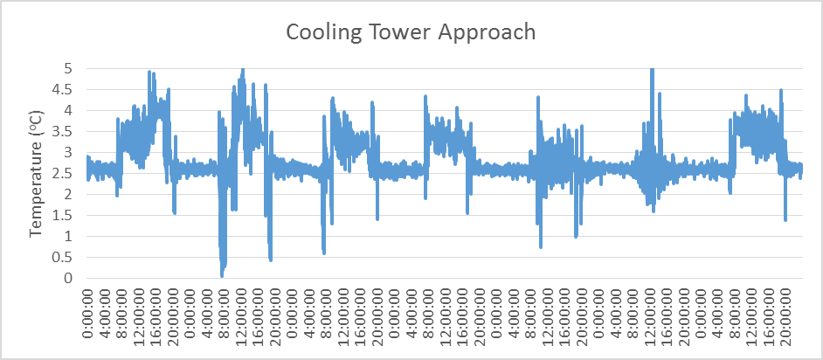

##### Figure 9: Cooling Tower Approach Temperature (Example)

*\*required if using wet bulb temperature as set point*

Figure 10: Super-imposed plot of daily chiller efficiency kW/RT (Example)

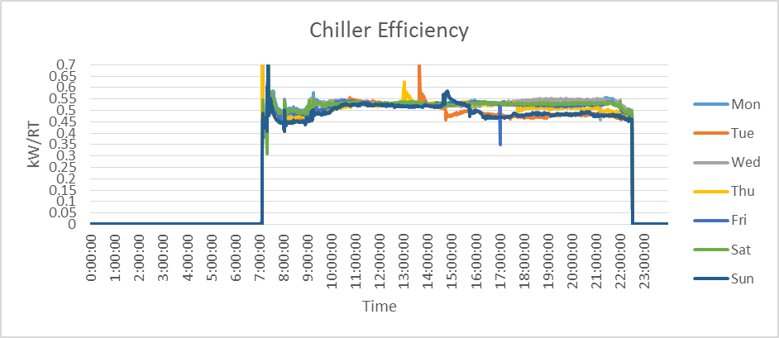

+

Weighted Ave

(10am-9pm) =

0.52

+

Weighted average: ∑ kW

-

hr / ∑ RT

-

hr

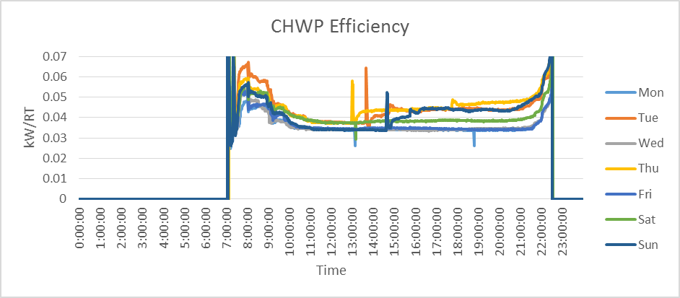

+

Weighted Ave

(10am-9pm) =

0.037

##### Figure 11: Super-imposed plot of daily chilled water pump efficiency kW/RT (Example)

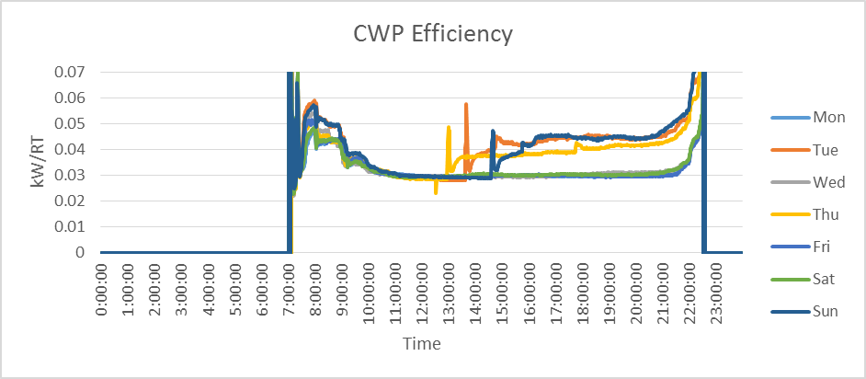

+

Weighted Ave

(10am – 9pm)=

0.031

##### Figure 12: Super-imposed plot of daily condenser water pump efficiency kW/RT (Example)

Figure 13: Super-imposed plot of daily cooling tower efficiency kW/RT (Example)

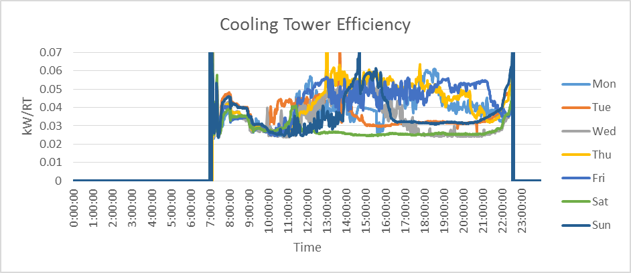

+

Weighted Ave

(10am-9pm)

0.038

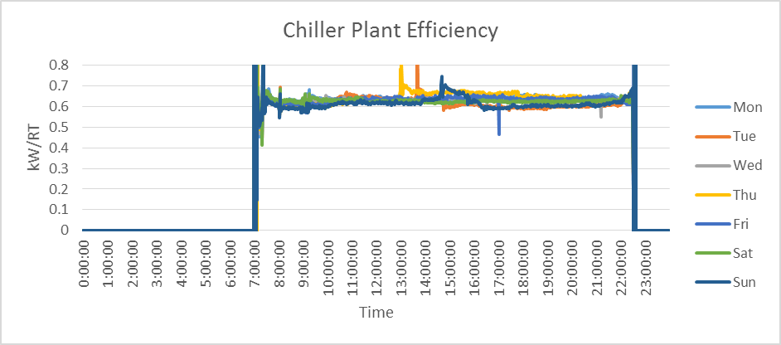

+

Weighted Ave

(10am-9pm)=

0.626

##### Figure 14: Super-imposed plot of daily chiller plant system efficiency kW/RT (Example)

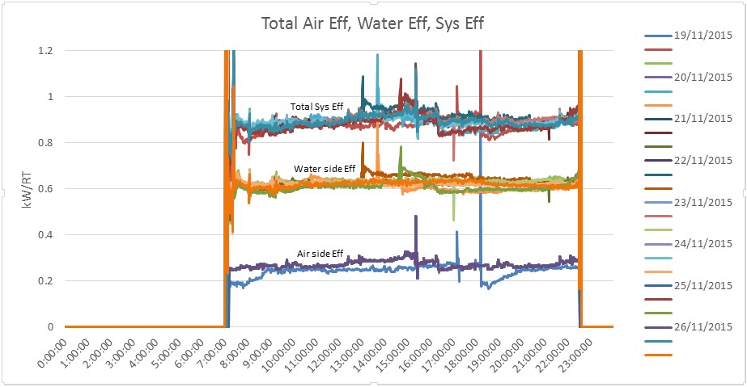

##### Figure 15: Super-imposed plot of daily total cooling system efficiency (**TSE**) kW/RT (Example)

***Note: TSE is required for GM: 2021 projects***

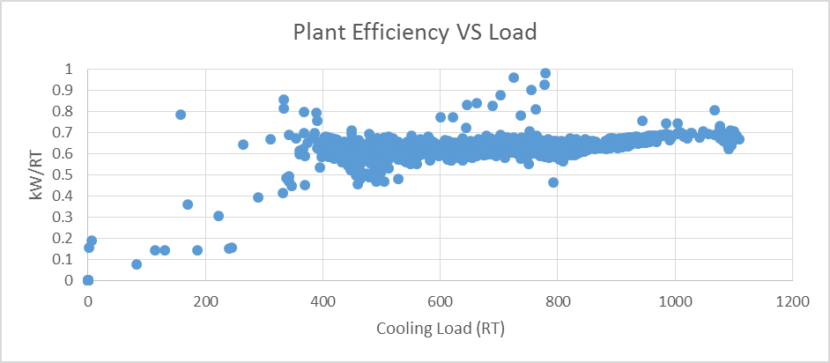

##### Figure 16: Scatter plot of chiller plant efficiency over cooling load (Example)

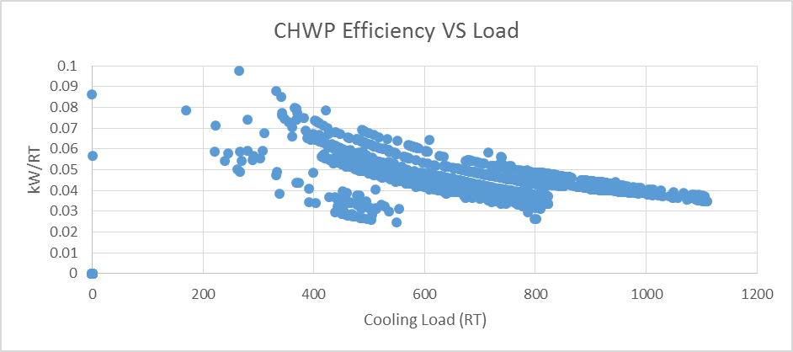

##### Figure 17: Scatter plot of chilled water pump efficiency over cooling load (Example)

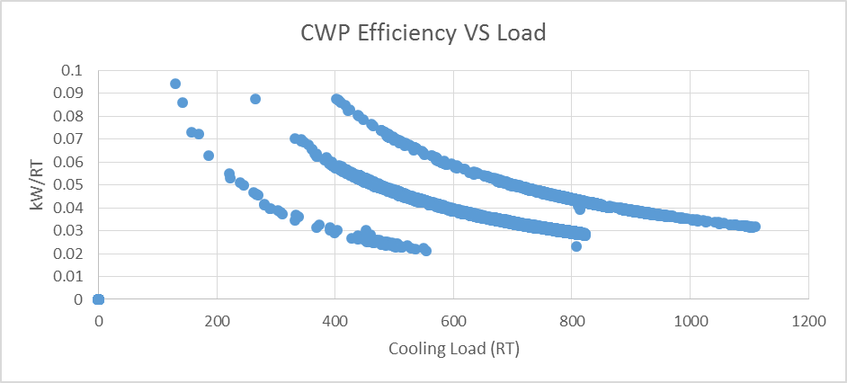

##### Figure 18: Scatter plot of condenser water pump efficiency over cooling load (Example)

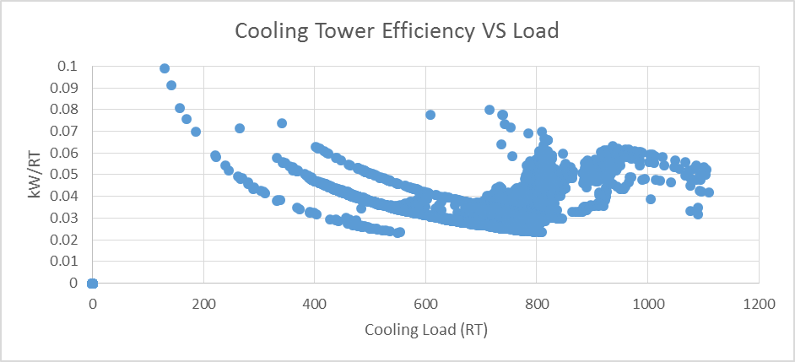

##### Figure 19: Scatter plot of cooling tower efficiency over cooling load (Example)

## 5.1 Summary of Chilled Water Plant Operating Performance

|  |  |  |  |
| --- | --- | --- | --- |
| **Daily Average Reading** | **Period** | | **Unit** |
| Daytime^ | Night-time~ |
| **Cooling Load** |  |  | RT |
| **Cooling Load Density (Air-con area)** |  |  | m2/RT |
| **Power Consumption (Chillers, Pumps, CTs)** |  |  | kW |
| **Power Consumption (AHUs, FCUs)** |  |  | kW |
| **Chilled water supply temperature** |  |  | oC |
| **Chilled water return temperature** |  |  | oC |
| **Chilled water delta T** |  |  | oC |
| **Chilled water flow rate** |  |  | l/s |
| **Chilled water flow rate vs cooling load** |  |  | USgpm/RT |
| **\*Condenser heat rejection** |  |  | HRT |
| **\*Condenser water supply temperature** |  |  | oC |
| **\*Condenser water return temperature** |  |  | oC |
| **\*Condenser water delta T** |  |  | oC |
| **\*Condenser water flow rate** |  |  | l/s |
| **\*Condenser water flow rate vs cooling load** |  |  | USgpm/RT |
| **Chiller(s) efficiency** |  |  | kW/RT |
| **Chilled water pump(s) efficiency** |  |  | kW/RT |
| **\*Condenser water pump(s) efficiency** |  |  | kW/RT |
| **\*Cooling tower(s) efficiency** |  |  | kW/RT |
| **Overall chiller plant efficiency** |  |  | kW/RT |
| **Overall airside efficiency** |  |  | kW/RT |
| **Total System efficiency (water + air)** |  |  | kW/RT |

Table 4: Total Cooling System Performance Summary

*Not applicable to air-cooled Chilled Water Plant

~For hotels and other developments with 24-hour operations only; Night-time shall refer to the period from 11pm – 7am;

^ For hotels and other developments with 24-hour operations, daytime refers to the period from 7am – 11pm; for all other developments, daytime shall refer to the normal operating hours stipulated in clause 6.1.4 of the PEA code

# 6.0 Summary of Heat Balance

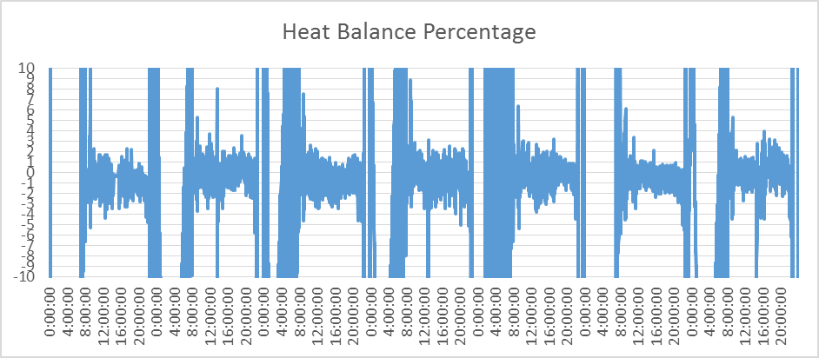

**±**

**5%**

##### Figure 20: System Level Heat Balance Plot

|  |  |  |  |
| --- | --- | --- | --- |
|  | **Quantity** | **Unit** | **Formula** |
| **Sum of total electrical energy used** |  | kWh | (A) |
| **Sum of total cooling produced** |  | RTh | (B) |
| **Sum of total heat rejected** |  | RTh | (C) |
| **Chiller Plant Efficiency** |  | kW/RT | (A) / (B) |
| **Total Heat Balance Data Count** |  | - | (D) |
| **Data Count > + 5% error** |  | - | (E) |
| **Data Count < - 5% error** |  | - | (F) |
| **Data Count within ±5% error** |  | - | (G) = (D) – (E) – (F) |
| **% Heat Balance within ±5% error** |  | % | 100 x (G) / (D) |

**Table 5: Heat Balance Summary**

# 7.0 Schedule of space operating conditions

***(10 points Spot measurements)***

|  |  |  |  |  |  |  |
| --- | --- | --- | --- | --- | --- | --- |
|  |  | **Normal operating room conditions** | |  | **Measured** | |
|  | **Room name**  **(i.e. Air conditioned occupied/ common Spaces)** | **Dry Bulb**  **Temperature**  **(oC)** | **Relative**  **Humidity**  **(%)** | **\*Dry Bulb**  **Temperature**  **(oC)** | **\*Relative**  **Humidity**  **(%)** | **\*CO2**  **Concentration (ppm)** |
| 1 | i.e. Office 1 |  |  |  |  |  |
| 2 | i.e. Office 2 |  |  |  |  |  |
| 3 | i.e. Meeting Room 1 |  |  |  |  |  |
| 4 | i.e. Meeting Room 2 |  |  |  |  |  |
| 5 |  |  |  |  |  |  |
| 6 |  |  |  |  |  |  |
| 7 |  |  |  |  |  |  |
| 8 |  |  |  |  |  |  |
| 9 |  |  |  |  |  |  |
| 10 |  |  |  |  |  |  |

**Table 6: Space Condition Schedule (Example)**

Note: Any observation on over-cooling/ under-cooling and ventilating of space conditions should first be investigated and corrected before the energy audit is carry out. Refer to recommended limits of SS553 and SS 554.

# APPENDIX A: Checklist of Plant Operating Condition (best practices)

|  |  |  |  |
| --- | --- | --- | --- |
| **Descriptions** | **Yes** | **No** | **Actual value** |
| **Is the airside efficiency ≤ 0.2 kW/RT?** |  |  |  |
| **Is Chilled water delta T >5.5 oC?** |  |  |  |
| **Is the cooling tower approach temperature ≤ 2.0 oC as compared with outdoor wet bulb temperature?** |  |  |  |
| **Is the Chilled water pump efficiency ≤ 0.03 kW/RT?** |  |  |  |
| **Is the Condenser water pump efficiency ≤ 0.035 kW/RT?** |  |  |  |
| **Is the Cooling Tower efficiency ≤ 0.03 kW/RT?** |  |  |  |
| **Does Refrigerant Condenser approach within the range of 0.5 oC to 1.5 oC?** |  |  |  |
| **Does Refrigerant Evaporator approach within the range of 0.5 oC to 1.5 oC?** |  |  |  |

**Table 7: Checklist of Plant Operating Condition (for best practices)**

# APPENDIX B: Temperature Sensor Verification Plot

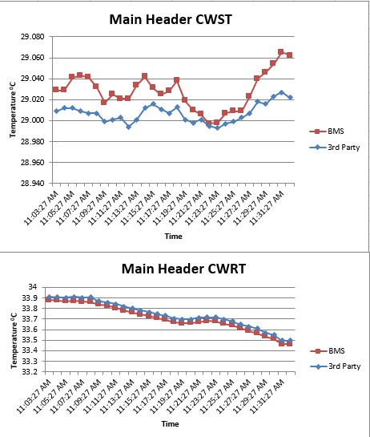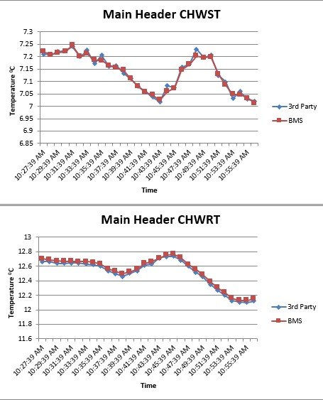

##### Figure 21: Temperature Verification Plots for Water-Cooled Chiller Plant System (Example)

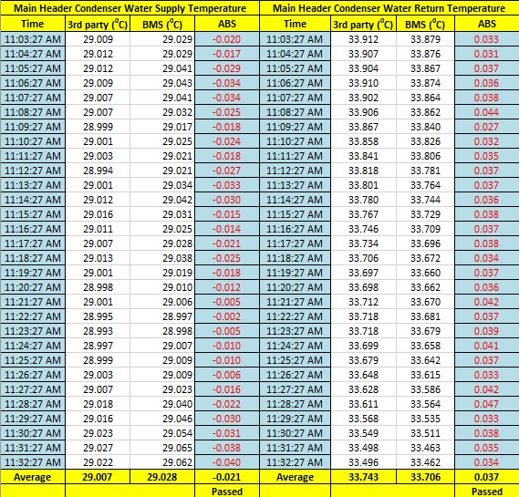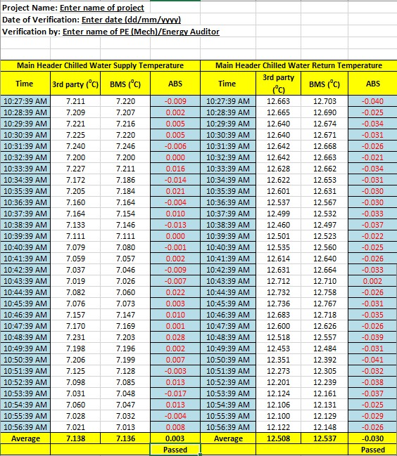

**Table 8: Verification of temperature sensors (example)**