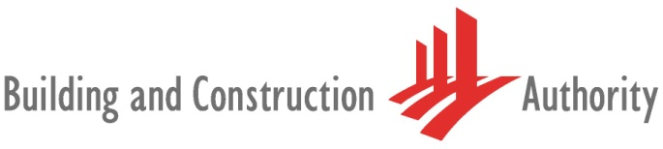
Mass Engineered Timber
(MET)

Information Kit
Revision 1.0 – May 2021

TABLE OF CONTENTS

- Introduction
- Regulatory requirements
  - BCA requirements
  - SCDF requirements
- Cost and Funding Support
- Design for Maintainability
  - Key Principles
  - Durability
    - Service Class
    - Ultraviolet (UV) Exposure
    - Termite Attack
    - Delivery
- Quality Assessment
- Logistics Management and Good Practices on Site
  - Shipping
  - Transportation
  - Temporary Storage and Protection
- Maintenance Regime
- Useful Resources

This information kit may be used for reference purposes only. Any reference herein to any specific practice does not constitute or imply BCA’s endorsement. Information is considered to be accurate at the time of publishing.

Information Kit for MET Projects

- Introduction
This information kit aims to share key information on MET with project teams, and serves as a guide to provide stakeholders with the necessary knowledge to MET construction.

Different sections of this kit may be more applicable to certain stakeholders. Each section is labelled with the target audience in mind. The table summarises the contents and respective target audience.
Section | Content | Developer | Consultant | Builder
2 | Regulatory requirements | √ | √ | √
3 | Cost premium | √ |  | √
4 | Design for maintainability |  | √
5 | Quality assessment | √ |  | √
6 | Logistics management and good practices on site |  |  | √
7 | Maintenance regime | √
8 | Useful resources  (Contacts, list of firms with track record in MET) | √ | √ | √

Developer
Consultant
Builder
- Regulatory Requirements
Project parties are advised to seek early pre-consultation (1-2 months before ST submission) with relevant agencies such as BCA and SCDF, to have greater clarity on the requirements.

  - BCA Requirements
The structural design of MET structures should comply with SS EN 1995 (Eurocode 5), and the relevant product codes BS EN 14080 (Glulam) and BS 16351 (CLT).

  - SCDF Requirements
All buildings constructed using MET should comply with the prevailing Fire Code. Section 9.9.5 of the code includes requirements specific to MET construction. The key requirements are:
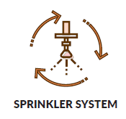 | 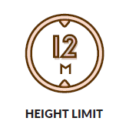 | 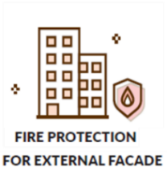 | 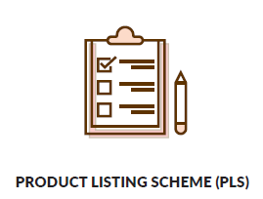
- MET buildings to be fully protected by automatic sprinkler systems  - May be exempted under certain conditions | - Healthcare: 12m  - Non-healthcare: No height limit. If > 12m, to adopt Performance Based (PB) approach, carried out by a Fire Safety Engineer (FSE) | - External façade should be non-combustible.  - If MET façade is exposed, Deluge system, or equivalent is required. | - Certified to Scheme 5*  - Fire test and annual factory audit required  Scheme 5 certification requires site inspection every 3,500m2, triggered by Declaration of Compliance (DoC).  Hence, project teams are encouraged to obtain Scheme 5 CoC before the DoC site inspections.
* Scheme 5 Certificate of Conformity (CoC) is required to obtain Temporary Fire Permit (TFP) and Fire Safety Certificate (FSC). The TFP / FSC would be used for application of Temporary Occupation Permit (TOP) and Certificate of Statutory Completion (CSC) respectively. The process of obtaining the CoC, including fire tests by overseas testing laboratories and certification by certifying bodies, may take about 6-9 months.
Builder
Developer
- Cost and Funding Support
The estimated cost premium for MET project is about 10 – 15% of the project cost. Funding support is available under the BuildSG Transformation Fund (PIP Scheme) to defray the cost of MET adoption. Support is on a case-to-case basis, and terms and conditions apply.

Consultant
- Design for Maintainability

  - Key Principles
Designing timber structures for maintainability is similar to other structures such as steel or concrete. The four key principles when designing for maintainability are:
- Forecast maintenance
- Access for maintenance
- Minimise maintenance interventions
- Enable simple maintenance
More information can be found in BCA’s Design Guide for Maintainability.

  - Durability
Upfront consideration should be given to prevent termite attacks, and potential discolouration of MET due to UV exposure. More information can be found in the MET Guidebook (see Section 8a).

    - Service Class
The appropriate service classes should be used, based on the environments the MET would be in. In Singapore, the service classes are generally Service Class 2 or 3.

Class 1 | Internal environment with negligible risk of decay or insect attack.
Class 2 | Unheated internal environments or with risk of occasional exposure to moisture.
Class 3 | Higher risk of wetting or higher moisture content than Service Class 2

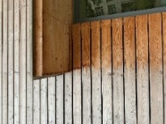
    - Ultraviolet (UV) Exposure
It is not recommended to use MET where there is direct exposure to weather, as MET can discolour. A protective coating or additional architectural cladding layer could be applied on the MET elements to reduce the impact of exposure to UV.

    - Termite Attack
The following could be taken to protect MET against termites:
Elevating timber from ground | Install physical barriers | Apply chemical treatment | Conduct regular inspection
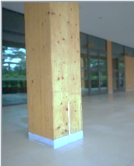 | 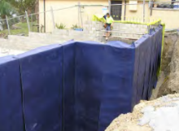 | 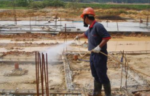  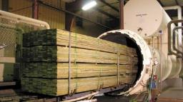 | 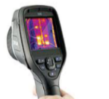
Ensure no direct contact between timber and ground | Using geotextile or mesh | Anti-termite treatment to the ground / timber | Checks on moisture content and presence of termites

    - Delivery
It is recommended to have a checklist for the Resident Engineer / site staff to check on the following when the MET is delivered to site:
- Quality of material (eg. grade, discolouration, cracks, dimensions, moisture content)
- Quality of assembly (eg. screws, bolts, steel plates, angles, brackets, connectors)

Developer
Builder
- Quality Assessment
The CONQUAS assessment standard for MET buildings are in CONQUAS 2019. The key requirements are:
- No stain marks and damages | - Voids to be filled if specified
- Visual finish surface to be planed and sanded | - No hollowness for exposed MET elements
- Crack tolerance  Domestic Grade Industrial and Standard Grade  Not more than 200 mm long and 2 mm width Not more than 400 mm long and 4 mm width | - Knot size tolerance  Domestic Grade Industrial and Standard Grade  Not more than 20 mm diameter Not more than 50 mm diameter

Builder
- Logistics Management and Good Practices on Site

  - Shipping
Transportation of MET from Europe to Singapore could take 8 to 10 weeks, after shop drawings are approved by client. It is advisable to finalise the key design parameters early, as subsequent changes to design may lead to delayed production and shipping.

  - Transportation
Auxiliary police escort is required if:
Height | > 4.5 metres (inclusive of truck height)
Width | ≥ 3.4 metres
Laden Weight | > 80 tonnes
Length | > 12 metres

  - Temporary Storage and Protection
Timber elements should be stored in a dry area free from potential damage. Good practices include:
- Sweep away standing water on MET elements.
- Protect the end grain to reduce moisture absorbed by MET.
- Stack MET components off the ground or on a levelled dry area to avoid soiling and distortion.
- Review moisture content prior to the application of finishes.

Developer
- Maintenance Regime
Regular building maintenance checks are applicable to all structures during their operational lifespan. Where treatment or coating is applied, as recommended by the supplier and/or specialists, there should be a maintenance regime for the reapplication of treatment or coating. Qualified persons should focus on the following checks applicable to timber structures:
Task | Checking Method | Frequency
Moisture content | Moisture meter | To be advised by PE  (Suggested: Annually for first 5 years, and subsequently once every 5 years)
End grain | Visual inspection
Insect and fungi attack
UV treatment
Corrosion
Significant cracks, delamination, warpage
Deflection (for long-span structure of more than 20m) | Measurement

Developer
Consultant
Builder
- Useful resources

- MET Guidebook [link]

- Firms with track record in MET [link]
- BCA Contact Person
Group | Name | Email
Construction Productivity and Quality | Lucas Loke | lucas_loke@bca.gov.sg
Building Engineering | Ng Kay Beng | ng_kay_beng@bca.gov.sg

- Product Listing Scheme
For enquiries on SCDF’s Product Listing Scheme, please contact any of the Certification Bodies below:
Certification Body |  | Contact Person | Email
Setsco Services Pte Ltd  [link] |  | Fiona Leong | fionaleong@setsco.com
 |  | Dixon Ng | ngds@setsco.com
Singapore Test Services  [link] |  | - | sales.sts@stengg.com
TUV SUD PSB Pte Ltd  [link] |  | - | Enquiries may be sent through TUV-SUD website

