Information Template to be submitted for Green Mark Assessment
Items | Remarks
Appendix A:  Mock Certificate and Publicity Information | To be checked and signed by the Client/Developer Representative.
Appendix B:  Project Factsheet | To be verified with assessor during Green Mark assessment.
Appendix C:  New Residential Buildings: Summary On Electricity Consumption  And Savings | To be verified with assessor during Green Mark assessment.
Appendix D:  Non-Residential Buildings: Summary On Electricity  Consumption And Savings | To be verified with assessor during Green Mark assessment.

Submitted by
Name
Designation
Email
Contact No
Date of submission

APPENDIX A: MOCK CERTIFICATE AND PUBLICITY INFORMATION
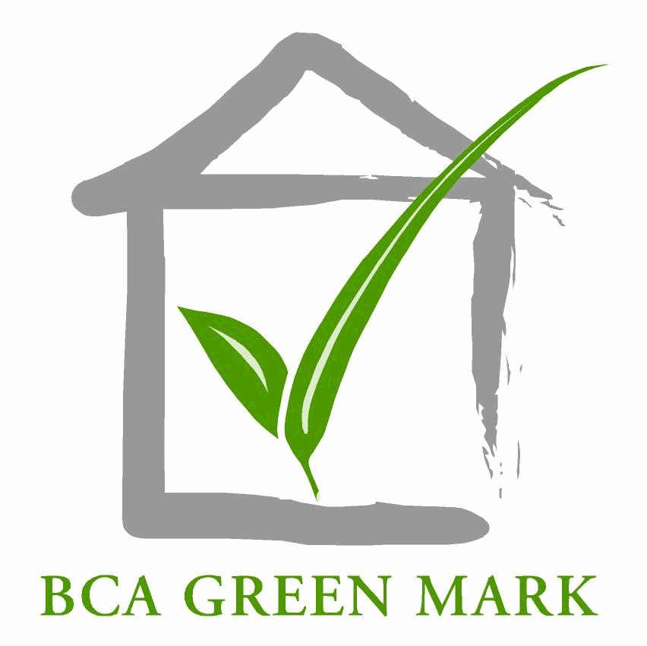
AWARD
(SLE/Platinum/GoldPLUS)
(do not strikethrough / delete. No award is confirmed until LOA is received
Presented to

(Actual project name)

(Address)

Contact person for Certificate / Plaque Collection
Expected TOP Date | 14/12/2022 |  | Name
Actual TOP Date (if received) |  |  | Designation
 |  |  | Email
 |  |  | Telephone

Key Contact Persons
Project Team | Name | Organisation | Designation | Contact No | Email
Applicant
Architect
Project Manager
1st Contact Person
2nd Contact Person
Green Mark Project
Coordinator
Page 2 of 6

Information for Green Mark Building Directory
Information released to public | Requirement
asdff  Full Name of Organisation  Client / Developer / Building Owner  Facility Management  Project Manager  Architect  M&E Engineer  Structural Engineer  Quantity Surveyor  Main Contractor  Landscape Consultant  ESCO / ESD Consultant  Others  (Pls specify)**  ** Please rename and state nature of consultancy  Number of Joint Venture Companies for Client/Developer/Owner  (if applicable) | Image MUST be included on this page. Please resize to fit in the rectangle given.  (A low resolution image may be used here for illustration purpose. This image must be the same as the high resolution soft copy)  Particularly for client/developer/building owner’s company, if the company is a subsidiary of another company, please ensure the main company’s name or the subsidiary company’s name should be used for the publicity. Information should be verified with main company. Please include all JV companies if applicable.  Project manager is only for company that involve solely for project management. In most cases, it should be left blank. It should not be the same as the main contractor.  Please ensure that punctuations, spellings of all company names are correct. Please check registered names at www.acra.gov.sg if necessary.  Please put “NA” for non-JV development (this refers to client/developer/owner only)

Information released to public | Requirement
Description of Project: (types of use, size, no. of storey, location etc)  Project Name:  GFA:  Project Address:  District Code:  List of other prominent green features  1  2  3  4  5  6  https://sleb.sg/Building/GreenmarkBuildingsDirectory | *Description is for publicity and is not the formal BP project description. It should be in structured sentence format limited to 3-4 sentences.  Note: A guide for number of features - 5 (GoldPLUS), 7 (Platinum). Additional green features that exceed the above stated number may not be published. Features should be arranged in the order of GM criteria with a full stop at the end of each point. Each green feature cannot be more than 20 words long.  Examples of standard phrases  - Chiller plant system with efficiency of 0.60kW/ton.  - Permanent measurement and verification instrumentation for the monitoring of chilled-water plant efficiency and heat balancing.

Information for Green Mark Building Directory
All information inputted in this appendix will be made available to public
Properties of this development (for search function)
Efficient Air-con System
Efficient lighting system
Integrated Energy Management & control Systems
Onsite or Offsite Renewable Energy
Use of Sustainable Material / Equipments
Use of UVGI system
Good Acoustic Control
Low Embodied Carbon
Use of Low Carbon Concrete
Use of Green Lease
Sustainable Procurement
Extensive Greenery
Use of Smart Facilities Management Technologies
Use of Robotics & Automation in FM
Use of BIM
Use of Smart Products

APPENDIX B: PROJECT FACTSHEET

Building Information
EUI (in kWh/m²/yr) |  | WWR (between 0 to 1)
ETTV Value (W/m²) |  | RETV value (W/m²)
Building Type
GFA (m²) |  | Air-Con Area (m²)
Carpark Area (m²) |  | Non Air-Con Occupied Area (m²)
Site Area (m²) |  | Non Air Con areas (circulation areas, common areas and M&E spaces)(m²)
Blocks |  | Storeys

Saving Details
Key KPIs | Estimated Saving | Remarks
Energy Saving |  | % saving compared to code compliance building
 |  | kwh energy saving per year (kwh/yr)
 |  | $ savings per year (assume $0.20 per kWh)
CO2 emission reduction per year |  | Express in tonne of CO2. (Singapore’s Grid Emission Factor (GEF) is 0.4085 kg CO2/kWh in 2019. 1 tonne of CO2 is equivalent to 1000kg of CO2. Overseas projects should use country’s GEF for calculations.)
Renewable energy |  | kWh collected per year
Page 1 of 3

Air-Conditioning Information
A/C system plant efficiency  (kW/ton) |  | Air side efficiency  (kW/ton)
Chiller configuration  (eg 2 x 500 tons) |  | Total System efficiency (kW/ton)
Total Cooling Load (tons) |  | Installed Cooling Capacity  (tons)
Cooling load (w/m2)  (Cooling Load per A/C areas) |  | Total Cooling Load x 3715 (W)  Air-Con Area (m²)
Main type of A/C system | Others, please specify
Page 2 of 3

Overall Cost of Green Building
(All values stated should be based on S$ )

Ref | Description | Value | Remarks
A | Construction /Retrofitting Cost $ (exclude GST)
B | Total floor Area (m²) |  | Include all covered area e.g. carpark
C | Unit construction / retrofitted Cost ($/m²) |  | A/B
D | Overall green premium cost ($) |  | Including EE & non EE
F | Overall % increase in construction cost due to green features (%)

Cost/Benefit of Green Features

Category | List of green features | Base cost  (A) | Investment cost  (B) | Green cost ($)  (C) = (B) – (A) | Potential savings  (kWh/yr for energy)  (D) | Potential saving ($/yr)  (D) x 0.2 | Payback on Premium (years)  (C)/(D)
Energy Efficiency | Air Conditioning System | $ 12,540,000 | $ 14,621,000 | $ 2,081,000 | 3,154,765 | $ 630,953 | 3.3
 | Artificial Lighting | $ 525,000 | $ 1,500,000 | $ 975,000 | 1,165,990 | $ 233,198 | 4.2
 | Lift System | $ 1,652,152 | $ 1,762,846 | $ 110,694 | 27,995 | $ 5,599 | 19.8
 | Total |  |  | $ 3,166,694 | 4,348,750 | $ 869,750 | 3.6

LCCA for Energy Efficiency Features

LCCA is used to determine the holistic cost of greening and identify the cost benefits of a BCA Green Mark Building over its lifecycle. The analysis also helps project team to understand how the net positive savings achieved during the building operation over its life span outweigh the upfront investment cost.

To provide the LCCA documentation - Pls attach the detailed LCCA (either in Excel or pdf form) under additional supporting documents section in GMO. The details must clearly demonstrate that the below mentioned parameters are used to conduct the LCCA.

Summary Table (numbers in the below table are for illustrative purpose only)

 | Green Mark Building Cost (Based on invested Cost) |  | Non-Green Mark Building Cost (Based on Base Cost)
Items | Total Building Escalated Life-Cycle Cost (30-years period) - $ | Total Building NPV Life-Cycle Costs (30-years period) - $ | Total Building Escalated Life-Cycle Costs (30-years period) - $ | Total Building NPV Life-Cycle Costs (30-years period) - $
Capex Cost | 31,638,800 | 31,638,800 | 27,247,680 | 27,247,680
Replacement Cost | 24,460,120 | 23,296,000 | 20,599,538 | 19,619,000
Operating (utilities) Cost | 40,292,318 | 19,576,000 | 79,028,095 | 38,395,000
Maintenance Cost | 33,424,891 | 16,866,000 | 29,704,845 | 14,975,000
End-of-Life Cost | 0 | 0 | 0 | 0
Life-Cycle Cost within Period (Total) | 129,816,130 | 91,376,800 | 156,580,159 | 100,236,680

Building GFA | 68915
NPV savings (B-A) | 100,236,680-91,376,800
NPV Savings/GFA | 129

Note:
- Electricity Tariff: use $0.2/kWh
- NPV: Net Present Value
- To calculate total building LCC, the team should consider capex cost, replacement cost, operating cost, maintenance cost and End – of life Cost
- Suggested Replacement Years
- Water-cooled chilled water system – 20 yrs.
- Air-cooled chilled water system – 15 yrs
- Unitary AC system – 10 yrs
- ACMV demand control – 10 & 20 yrs.
- Mechanical Ventilation System – 15 yrs.
- BIPV/PV – 15 yrs.
- Lift & Escalators – 20 yrs.
- Heat Pumps – 20 yrs.
- Parameters for LCC
- Building Life Span – 30 yrs.
- Escalation Rate (p.a) - 1.5%
- Discount Rate - 5.0%
- Incremental Maintenance – 3.0%
- Utilise Cost – 0.2/kWh
- Façade Maintenance – 1$/sqft

Cost of Other Green Features (Non-Energy related)
Category | List of green features | Green cost (S$)
Intelligence
Health and Wellbeing
Whole of life Carbon
Maintainability
Resilience
 | Total cost

APPENDIX C: NEW RESIDENTIAL BUILDINGS: SUMMARY ON ELECTRICITY CONSUMPTION AND SAVINGS
Items | Estimated  Load (kW) | Daily Usage  (hr)* | Load per day  (kWh)
 | A | B | A X B
* Hours used is based on a typical residential building
Items | Formula | Value
Total kWh per day | ∑ (AxB)
Total Energy Consumption per year (kWh/year) for common areas | ∑ (AxB) x 365
Gross Floor Area (m²) | C
EEI for Common Facilities (kWh/m²/yr) EEI-Common  (item to update for appendix B) | [∑ (AxB) x 365]  C
Page 1 of 2

ELECTRICITY CONSUMPTION FOR DWELLING UNITS A/C
 |  | Estimated Load (kW) |  | Daily Usage (hr) | Load per day (kWh)
A/C load for all apartment units |  |  |  | 8
Total kWh per day (D)
 | Items |  | Formula |  |  | Value
 | Total Energy Consumption per year (kWh/year) for all units A/C |  | D x 365
 | Gross Floor Area (m²) |  | C
 | EEI for all units A/C (kWh/m²/yr)) EEI-A/C |  | D x 365  C

ESTIMATED ENERGY SAVING PER YEAR FOR GREEN FEATURES
Green Features | Estimated Energy Saving  Per Year# (kWh) | Distribution of Energy Saving*  (%)
Dwelling Units A/C
Lighting for common areas
Car Park MV System
Others
Total Energy Saving
* Distribution of energy saving is percentage of estimated energy saving per year for each green features over total energy consumption per year for both common areas and all units A/C
# Details calculation of energy saving for each green features shall be enclosed

APPENDIX D: NON-RESIDENTIAL BUILDINGS: SUMMARY ON ELECTRICITY CONSUMPTION AND SAVINGS

NEW NON-RESIDENTIAL BUILDINGS (Applicable for pathway 3)
System/ Equipment | Proposed Model Energy Consumption (kWh/yr) (A) | Reference Model Energy Consumption (kWh/yr)  (B) | Energy Savings (%)  (A-B)/A
Total Building Energy Consumption
The above table should be based on actual receptacle load. Please include another table if 25% cap on receptacle load is applied.
Items listed are based on typical building. Items could be added for better description.
- Chilled Water System (chillers, water pumps and cooling towers)
- Chilled Water Air Handling and Fan Coil Units
# Details calculation of energy saving for each SYSTEM shall be enclosed

EXISTING NON-RESIDENTIAL BUILDINGS
State the scope of the green / energy efficient improvement works.  E.g. replacement of chiller plant, installation of T5 lightings, LED,  CO sensor for carpark, etc. | Total Building Energy Consumption BEFORE retrofit (kWh/yr)  (A) | Estimated Total Building Energy Consumption AFTER retrofit (kWh/yr)  (B) | Energy savings (%)  (A-B)/A
Total Building Energy Consumption

