How to produce the Green Mark Decal or Plaque?
The Green Mark Decal or Plaque can be produced by adhering to the specification as shown below. The Decal/plaque will be imprinted with the Green Mark Certification Rating and Year of Attaining Certification; therefore, customisation is required for each of the project/ building. The correct information shall be used for the GM decal / plaque.

Specification for GM Decal

Artwork for variations of GM Rating for Year 2023:
Platinum  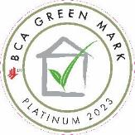 | Platinum Super Low Energy (SLE)  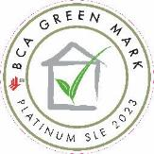 | Platinum Zero Energy (ZE)  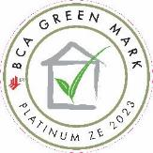 | Platinum Positive Energy (PE)  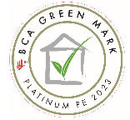

Gold^{PLUS}  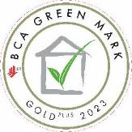 | Gold^{PLUS} Super Low Energy (SLE)  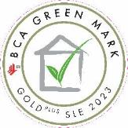 | Gold^{PLUS} Zero Energy (ZE)  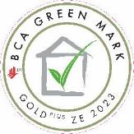 | Gold^{PLUS} Positive Energy (PE)  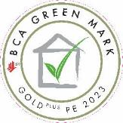

Gold  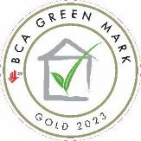 | Certified  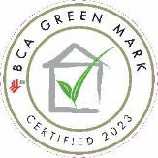

Super Low Energy (SLE)  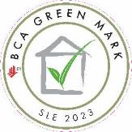 | Zero Energy (ZE)  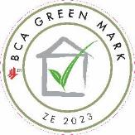 | Positive Energy (PE)  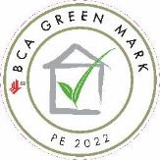

Artwork for variations of GM Rating for Year 2022:
Platinum  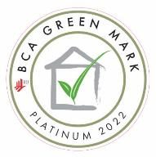 | Platinum Super Low Energy (SLE)  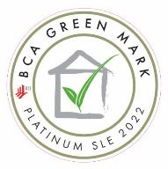 | Platinum Zero Energy (ZE)  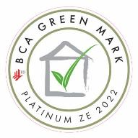 | Platinum Positive Energy (PE)  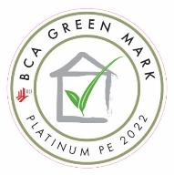

Gold^{PLUS} 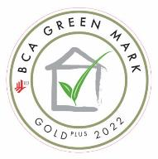 | Gold^{PLUS} Super Low Energy (SLE)  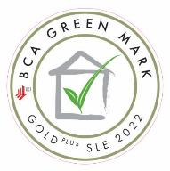 | Gold^{PLUS} Zero Energy (ZE)  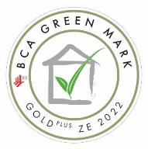 | Gold^{PLUS} Positive Energy (PE)  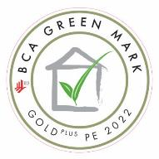

Gold  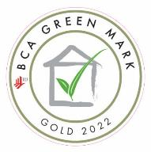 | Certified  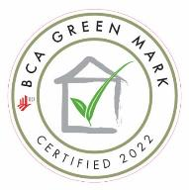

Super Low Energy (SLE)  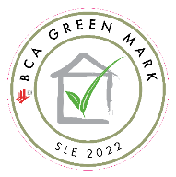 | Zero Energy (ZE)  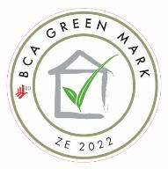 | Positive Energy (PE)  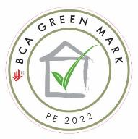

GM Certification Rating: The digital artworks are provided above. Developer/building owner is to use the artwork which correctly reflected the attained GM Certification Rating to reproduce the artwork.

Year of Attaining GM Certification: Inscription Year varies depending on the year of award for the project. Inscription Year for new building is the TOP year or the year receiving the letter of awards whichever is later, while for existing building and user centric scheme is the year receiving the letter of awards. Please make changes of the year accordingly.

Decal Size: Circular sticker, 300mm Diameter for the external circle stroke; 270mm Diameter for the internal circle stroke
Paper: Transparent Clear, removal sticker or, 3M sticker quality equivalent
Print quality: Laminated inkjet full color print, scratchproof and waterproof
Format of print: Front print
BCA GM wording Font: AGaramond Bold, 78pt size, 400 tracking
GM Certification Rating Font: AGaramond Bold, 65pt size, 280 tracking

BCA Logo colour: PMS Red 032, Cyan 0%, Magenta 91%, Yellow 87%, Black 0%
BCA GM Logo colour: 40% black, pantone 369CVC, 20% Pantone 369CVC
BCA GM Logo Font: AGaramond Bold
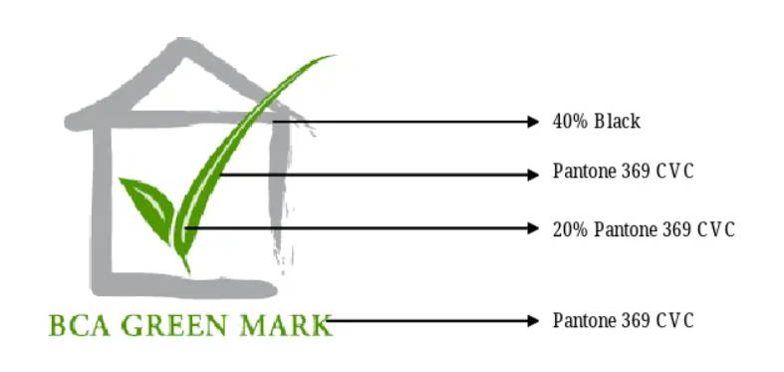

Specification for GM Plaque
The Green Mark Plaque design shall be same as the GM decal design, which shall include inscription of the GM Certification Rating, Year of the GM Certification, BCA logo and BCA GM logo. The building owners can select their preferred material to produce GM plaque.
Example of Green Mark Decal or Green Mark Plaque
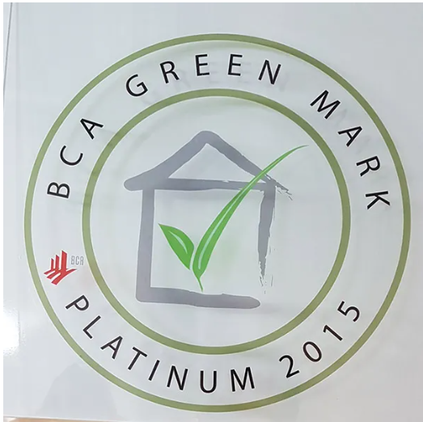 | 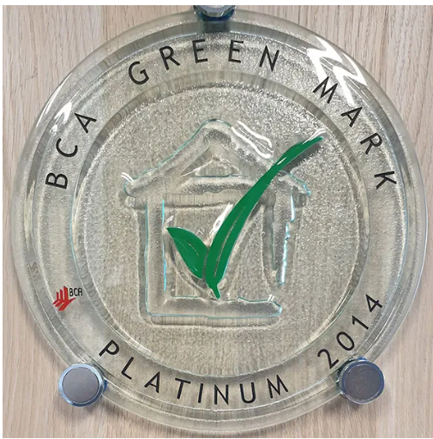
The Decal, a transparent 'sticker' (approximately 300mm dia.), is suitable for affixing onto plain surface or glass. | The Green Mark Plaque can be custom-made (approximately 300mm dia.)

